Robotic Sorting System

Pace Dominy

Joseph Miller

Lam Tran

**Functional System Requirements**

Draft Release

3 October 2022

Functional System Requirements

for

Robotic Sorting System

Prepared by:

_____________________________

Author Date

Approved by:

_____________________________

Project Leader Date

_____________________________

John Lusher, P.E. Date

_____________________________

T/A Date

**Change Record**

|  |  |  |  |  |
| --- | --- | --- | --- | --- |
| **Rev.** | **Date** | **Originator** | **Approvals** | **Description** |
| **-** | 10/3/2022 | Robotic Sorting System |  | Draft Release |

**Table of Contents**

**Table of Contents III**

**List of Tables IV**

**No table of figures entries found. IV**

**List of Figures V**

**1.** **Introduction 1**

1.1. Purpose and Scope 1

1.2. Responsibility and Change Authority 1

**2.** **Applicable and Reference Documents 2**

2.1. Applicable Documents 2

2.2. Reference Documents 2

2.3. Order of Precedence 3

**3.** **Requirements 4**

3.1. System Definition 4

3.2. Characteristics 4

3.2.1. Functional / Performance Requirements 4

3.2.2. Physical Characteristics 5

3.2.3. Electrical Characteristics 6

3.2.4. Environmental Requirements 8

3.2.5. Failure Propagation 9

**4.** **Support Requirements 10**

**Appendix A Acronyms and Abbreviations 11**

**Appendix B Definition of Terms 12**

**Appendix C Interface Control Documents 12**

**List of Figures**

Figure 1. Conceptual Image for the Robotic Sorting System 5

# Introduction

## Purpose and Scope

The Robotic Sorting System is an automated system that uses size, color, and weight sensing to automatically sort fruit. The fruit is placed on the conveyor belt, which carries the fruit to the sensing area where a camera-equipped Raspberry Pi determines the size and color information used to sort the fruit. The system then decides what “bin” to sort the fruit into. The conveyor belt then carries the fruit to the robotic sorting arms/guiding rails, which guide the fruit to the correct bin. An overall system diagram is shown in Figure 1 illustrating the primary subsystems and their relationships to each other.

Figure . Conceptual Image for the Robotic Sorting System

This Functional System Requirements (FSR) document defines the technical requirements for both the Robotic Sorting System and its primary subsystems.

## Responsibility and Change Authority

Each member of the team is responsible for ensuring that their subsystem meets the stated requirements as shown in Figure 2 below. However, the team leader (Pace Dominy) is responsible for ensuring that the project as a whole meets the stated requirements. The requirements stated in this document may only be changed with the approval of the team leader and Dr. John Lusher.

|  |  |
| --- | --- |
| **Subsystem** | **Responsibility** |
| Android Application | Joseph Miller |
| Conveyor Belt | Pace Dominy |
| Power Control | Pace Dominy |
| Robotic Levers | Pace Dominy |
| Sensors | Lam Tran |

# Applicable and Reference Documents

## Applicable Documents

The following documents, of the exact issue and revision shown, form a part of this specification to the extent specified herein:

|  |  |  |
| --- | --- | --- |
| **Document Number** | **Revision/Release Date** | **Document Title** |
| ANSI/NFPA 70 | 2023 | National Electrical Code |
| Bluetooth SIG 5.0 | 06 December 2016 | Bluetooth Core Specification v5.0 |

## Reference Documents

The following documents are reference documents utilized in the development of this specification. These documents do not form a part of this specification and are not controlled by their reference herein.

|  |  |  |
| --- | --- | --- |
| **Document Number** | **Revision/Release Date** | **Document Title** |
|  | June 2019 | Raspberry Pi 4 Module B Datasheet |
|  |  |  |

## Order of Precedence

In the event of a conflict between the text of this specification and an applicable document cited herein, the text of this specification takes precedence without any exceptions.

All specifications, standards, exhibits, drawings or other documents that are invoked as “applicable” in this specification are incorporated as cited. All documents that are referred to within an applicable report are considered to be for guidance and information only, except ICDs that have their relevant documents considered to be incorporated as cited.

# Requirements

## System Definition

The Robotic Sorting System is an automatic sorting system meant for small farms that can’t afford a large scale and expensive sorting system for sorting their produce. The Robotic Sorting System will allow farmers to allocate very little manpower to sorting and allow them to instead focus on more labor-intensive tasks. Different setups of the system will be allowed such as changing the number of channels/receptacles based on the needs of the farmer.

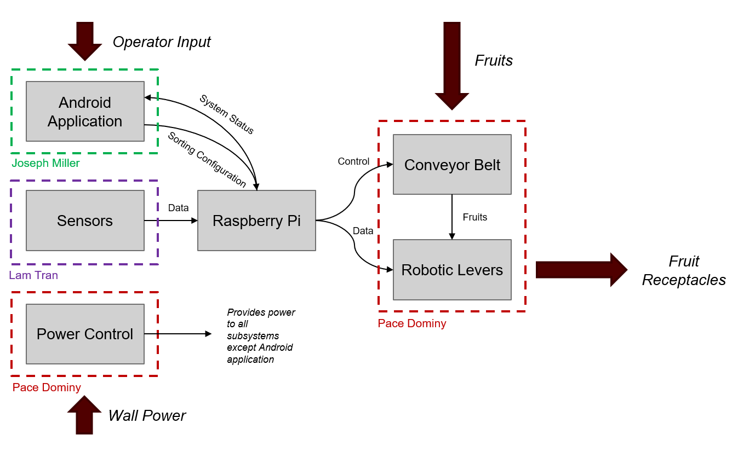

Figure . Block Diagram of System

Fruit will travel onto the conveyor belt one at a time where they will briefly stop while the camera takes a picture. From here, the Raspberry Pi will determine the type and quality of the fruit via image processing. Next, the raspberry pi will tell the guiding belt to move the lever arms/guiding rails into the correct position to guide the fruit to the correct receptacle. The belt will then start up again and the fruit will be moved down the belt between the guiding arms into the corresponding receptacle. Each receptacle will have a load cell (weight sensor) which will be used to determine how much fruit is in the receptacle.

The mobile application will be used to remotely start and stop the sorting system as well as configure the system to look at different criteria when sorting. The user manual and contact information will also be available through the application. Finally, the app will also allow troubleshooting of problems that occur with the system.

## Characteristics

### Functional / Performance Requirements

#### Processing Speed

The Robotic Sorting System shall be able to sort at least 6 fruits per minute.

*Rationale: If the sorting speed is too slow, the sorting machine will not be a worthwhile investment (versus simply sorting the fruit by hand). However, if the sorting speed is too fast, it may cause damage to the fruit or even cause the fruit to fall off of the machine. A sort time per fruit of approximately 10 seconds allows the fruit to move quickly through the system without the risk of damage.*

#### Sorting Accuracy

The Robotic Sorting System shall be able to sort fruit based on the user-specified criteria with at least 95% accuracy.

*Rationale: Much like processing speed, good accuracy is key to ensuring that the Robotic Sorting System is a worthwhile upgrade over human sorting. An accuracy of 95% allows some room for error while remaining highly accurate.*

#### Sequential Sorting

The Robotic Sorting System shall classify and scan only one fruit at a time.

*Rationale: While parallel sorting would greatly increase the throughput of the Robotic Sorting System, maintaining 95% accuracy on parallel tracks would likely require better sensors or more sensors, neither of which are financially viable for this system.*

#### Number of Sorting Categories

The Robotic Sorting System shall support at least three sorting categories (or “bins”).

*Rationale: A Robotic Sorting System that supports at least three different bins provides significant added utility compared to a system only capable of sorting into two bins for little additional extra complexity. While there is a possibility to add greater than 3 bins, adding more bins will quickly face diminishing returns compared to the amount of complexity added to the system.*

### Physical Characteristics

#### Mass

The mass of the Robotic Sorting System shall be less than or equal to 160 kilograms.

*Rationale: The Robotic Sorting System must be light enough for it to be portable while having enough mass to be stable and robust. 160 kilograms is a good balance for portability and robustness.*

#### Volume Envelope

The volume envelope of the Robotic Sorting System shall be less than or equal to 34 inches in height, 28 inches in width, and 64 inches in length.

*Rationale: For height, 34 inches is about half of the average height of an adult male. So having 34 inches for the height should be manageable for the farmer. For the width, 28 inches is a reasonable width for 3 receptacles. For length, 64 inches is a reasonable length for the robotic lever to guide fruits to a certain channel.*

#### Mounting

Mounting information for the Robotic Sorting System shall be provided in the ICD.

#### Level surface

The level surface for the Robotic Sorting System has a height of 34 inches. The conveyor belt has a rough surface.

*Rationale: The rough surface of the conveyor belt will keep the fruits steady when they are on the conveyor.*

#### Specified set up for connection to another conveyor belt

The specified set up for connection to another conveyor belt for the Robotic Sorting System shall be provided in the user manual.

#### Table

The table of the Robotic Sorting System is the section between the conveyor belt and receptacles. There are channels within the table that guide the fruit into its receptacles.

#### Food safety of all components

The material of the conveyor belt, the robotic lever, the channels, and the receptacles are food grade. They won’t leach chemicals to the fruits, they can be sanitized, and they are FDA approved.

*Rationale: What components will touch the fruits? The conveyor belt, the robotic lever, the channels, and the receptacles.*

* + 1. **Electrical Characteristics**

Figure . Power System Diagram

#### Inputs

The inputs for the Robotic Sorting System include power from a wall outlet, images from the Raspberry Pi Camera and resistance measurements from the load cells. An owner of the system can also configure the sorting criteria of the system via a Bluetooth connection on an Android device with the app designed for the system.

*Rationale: Batteries are inconsistent and it is better to use a national standard for power input*

##### Input Voltage Level

The input voltage level for the Robotic Sorting System shall be 120 VAC.

*Rationale: 120 VAC is standard for most outlets (except of course 240 VAC for larger home appliances)*

##### Resistance to Power Surges/Cutoffs From Mains

The Power Subsystem will be resistant to power surges in order to prevent destruction of the circuit.

#### Outputs

##### Data Output

Weight data will be outputted to the Android app over Bluetooth.

##### Diagnostic Output

The Robotic Sorting System shall include a page for diagnostics in the Android application for troubleshooting issues. Diagnostic data will be sent over Bluetooth to the Android app.

#### Connectors

Connectors will be done in accordance with ANSI/NFPA 70.

*Rationale: All states follow this standard, at least according to the NFPA website.*

#### Wiring

Wiring will be done in accordance with ANSI/NFPA 70.

### Environmental Requirements

The Robotic Sorting System shall be designed to withstand and operate in the environments and laboratory tests specified in the following section.

*Rationale: This is a requirement specified by our customer due to constraints of their system in which the Search and Rescue System is integrating.*

#### Heat Resistance

The Robotic Sorting System shall be designed to withstand and operate the temperature of 36 to 100 degree Fahrenheit.

*Rationale: Some fruits are seasonal. Example: tomatoes are harvested in the summer and tangerines are harvested in the winter.*

#### Water Resistance

The Robotic Sorting System shall be designed to withstand and operate in a wet or humid environment.

*Rationale: Ideally, the system would be operated inside a warehouse with fruits that are clean and not covered with water. But for some farms, this might not be the case. Like cranberries for example, since they are submerged in water. So some farmers might want to use the system outside, exposed to the element.*

#### Dust Resistance

The Robotic Sorting System shall be designed to withstand and operate in a dusty environment.

*Rationale: Some farms are located in arid deserts. Prickly pears is an example. So dust from the environment should be something to consider for the design of the system.*

### Failure Propagation

In the event of a failure of some sort, the Robotic Sorting System will halt operation and return an error message to the operator via the Android application.

#### Causes for Failure

The Robotic Sorting System shall be capable of detecting the following failure conditions. In all of the following cases, all subsystems shall immediately cease operation except the Android app, which will show a popup explaining the system fault.

#### Belt Blockage

The Robotic Sorting System shall stop operation if the conveyor belt is blocked.

*Rationale: If the system continues to run while the belt cannot move, the motors that drive the conveyor belt may be damaged.*

* + - * 1. **Fruit Blockage**

The system shall stop operation if, at any point in the physical flow of fruit, a fruit physically blocks the flow of fruit.

*Rationale: If the system continues to run while a fruit is blocking others, the rest of the fruit will physically spill off of the machine. Additionally, depending on the fruit, the jam may cause the fruit to be crushed and spill juices, potentially causing damage to the system.*

* + - * 1. **Sensor Fault**

The system shall stop operation if any of the three classes of sensors (weight, color, or size) cannot reliably detect the requisite physical attribute.

*Rationale: Much like the case of a linear actuator failure, the Robotic Sorting System is not capable of sorting fruit if it cannot detect the differences between fruit.*

# Support Requirements

The Robotic Sorting System requires power and an Android device with Bluetooth capabilities that can download the free application that goes with the system. One sorting system consists of (1) conveyor belt, (1) guide belt, (2) lever arms/guiding rails, (1) raspberry pi 4, (1) raspberry pi camera, (3) receptacles with load cells minimum, (1) printed circuit board and (1) user manual.

# Appendix A: Acronyms and Abbreviations

Below is a list of common acronyms and abbreviations, updated based upon your project….

GUI Graphical User Interface

ICD Interface Control Document

kHz Kilohertz (1,000 Hz)

kW Kilowatt (1,000 Watts)

LCD Liquid Crystal Display

LED Light-emitting Diode

mA Milliamp

mW Milliwatt (1 thousandth of a Watt)

PCB Printed Circuit Board

USB Universal Serial Bus

VAC Voltage with AC (alternating current)